

**Lesson 5 Lesson-End Project**

**Performing Ether Transactions in Metamask**

|  |
| --- |
| **Project Agenda:** To perform an Ethereum transaction on a test network  **Description:** You are a Blockchain expert in a Fintech enterprise and have been tasked to credit salaries to all employees in Ethers.  **Tools required:** Ubuntu, Web browser, Metamask, Ganache/Test Ether Faucet  **Pre-requisites:** Lesson 5 Demo 3, 4, 5, 6, and Ether Faucet (<https://faucet.ropsten.be/>)  **Expected Deliverables:** To simulate a transaction worth certain Ethers on the Ethereum test network |

**Steps to be followed:**

1. Installing Metamask and creating a wallet
2. Installing Ganache and configuring a private Blockchain
3. Connecting the Metamask account to Ganache or a test faucet to obtain Ethers
4. Performing an Ether transaction from one Metamask account to another

**Step 1: Installing Metamask and Creating a Wallet**

1. Refer to Lesson 5 Demo 5 to install and set up a Metamask wallet

**Step 2: Installing Ganache and Configuring a Private Blockchain**

1. Refer to Lesson 5 Demo 3 to install Ganache into your local machine
2. Refer to Lesson 5 Demo 4 to configure a private Blockchain using Ganache

**Step 3: Connecting Metamask to Ganache or a Test Faucet to Obtain Ethers**

1. Refer to Lesson 5 Demo 6 to connect the Metamask wallet to Ganache
2. If you prefer to use a test faucet for Ethers, you can visit <https://faucet.ropsten.be/>, enter your account address, and click **Send me test Ether** to obtain a few Ethers for this demo  
   Alternate Faucet: <https://faucet.dimensions.network/>  
     
   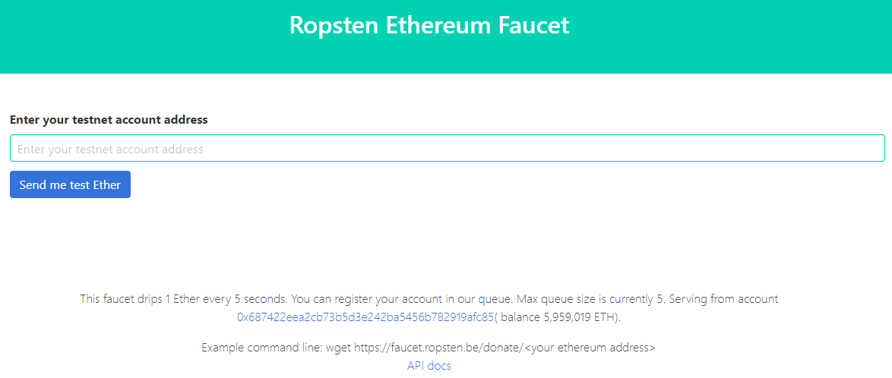

|  |
| --- |
| **Note:** You may use either method to obtain test Ethers. A test faucet may serve only a limited number of Ethers in a period whereas Ganache can be configured to serve any amount of Ether required. |

**Step 4: Performing a Transaction from One Metamask Account to Another**

1. Connect to the **Ropsten Test Network** to simulate a salary transaction

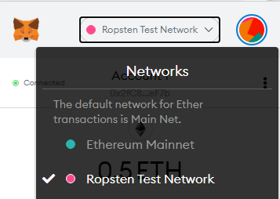

1. Select the account you want to debit the amount/salary from. This represents the enterprise account  
     
   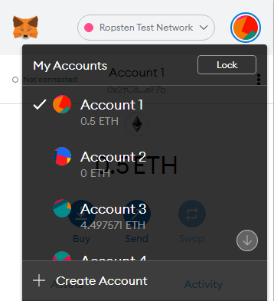
2. Click the **Send** button to initiate a transaction

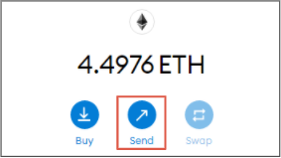

1. Add the recipient’s address and press **Enter** to select the intended user

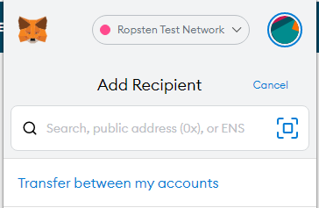

1. After the correct address is entered, we are asked to enter the amount which is **2 ETH**, we can adjust the **Gas Price** and **Gas Limit** according to our interests**,** and initiate the transaction  
   **Gas Limit is 21000  
   Gas Price is 2**The higher transaction fee a user is willing to pay, the faster the transaction will be processed and validated, and vice versa

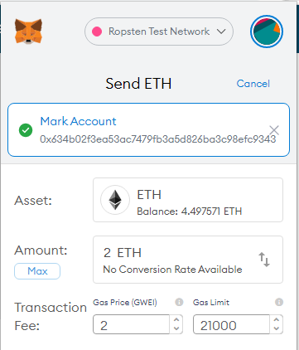

1. After confirming the transaction, it is added to an emulated mining pool, and the user has to wait a few seconds for the transaction to be completed

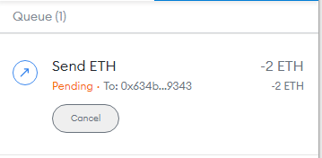

1. The transaction details will be displayed once the transaction is completed

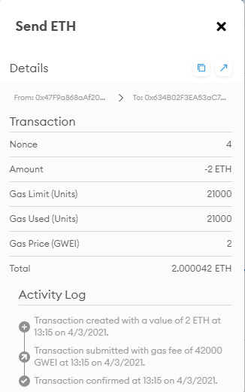

1. Click on the **Arrow Icon** in the top-right corner to view the elaborate transaction details on Etherscan

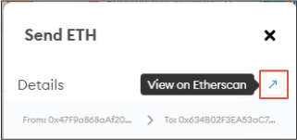

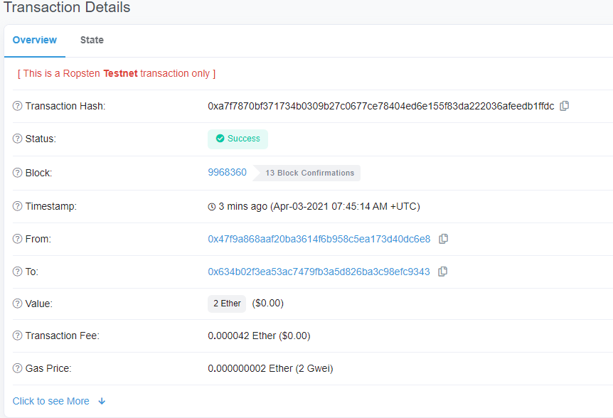

The complete transaction information is displayed on Etherscan